Massage Client Intake and Consent Form
Name ___________________________________________________________ Date of Birth _____________________________
Address _________________________________________________ City _________________________________ State ___________ Zip | ______________

Phone _______________________________________________________________ Email ____________________________________________________________

Employer ________________________________________________________ Occupation ________________________________________________________

How did you hear about us? ______________________________________________ Referred By _____________________________________________

In Case of Emergency, Contact _______________________________ Phone ______________________________ Relationship __________________

Are you currently under the care of a Physician?  Yes  No

If yes, name of Physician and reason ______________________________________________________________________________________________

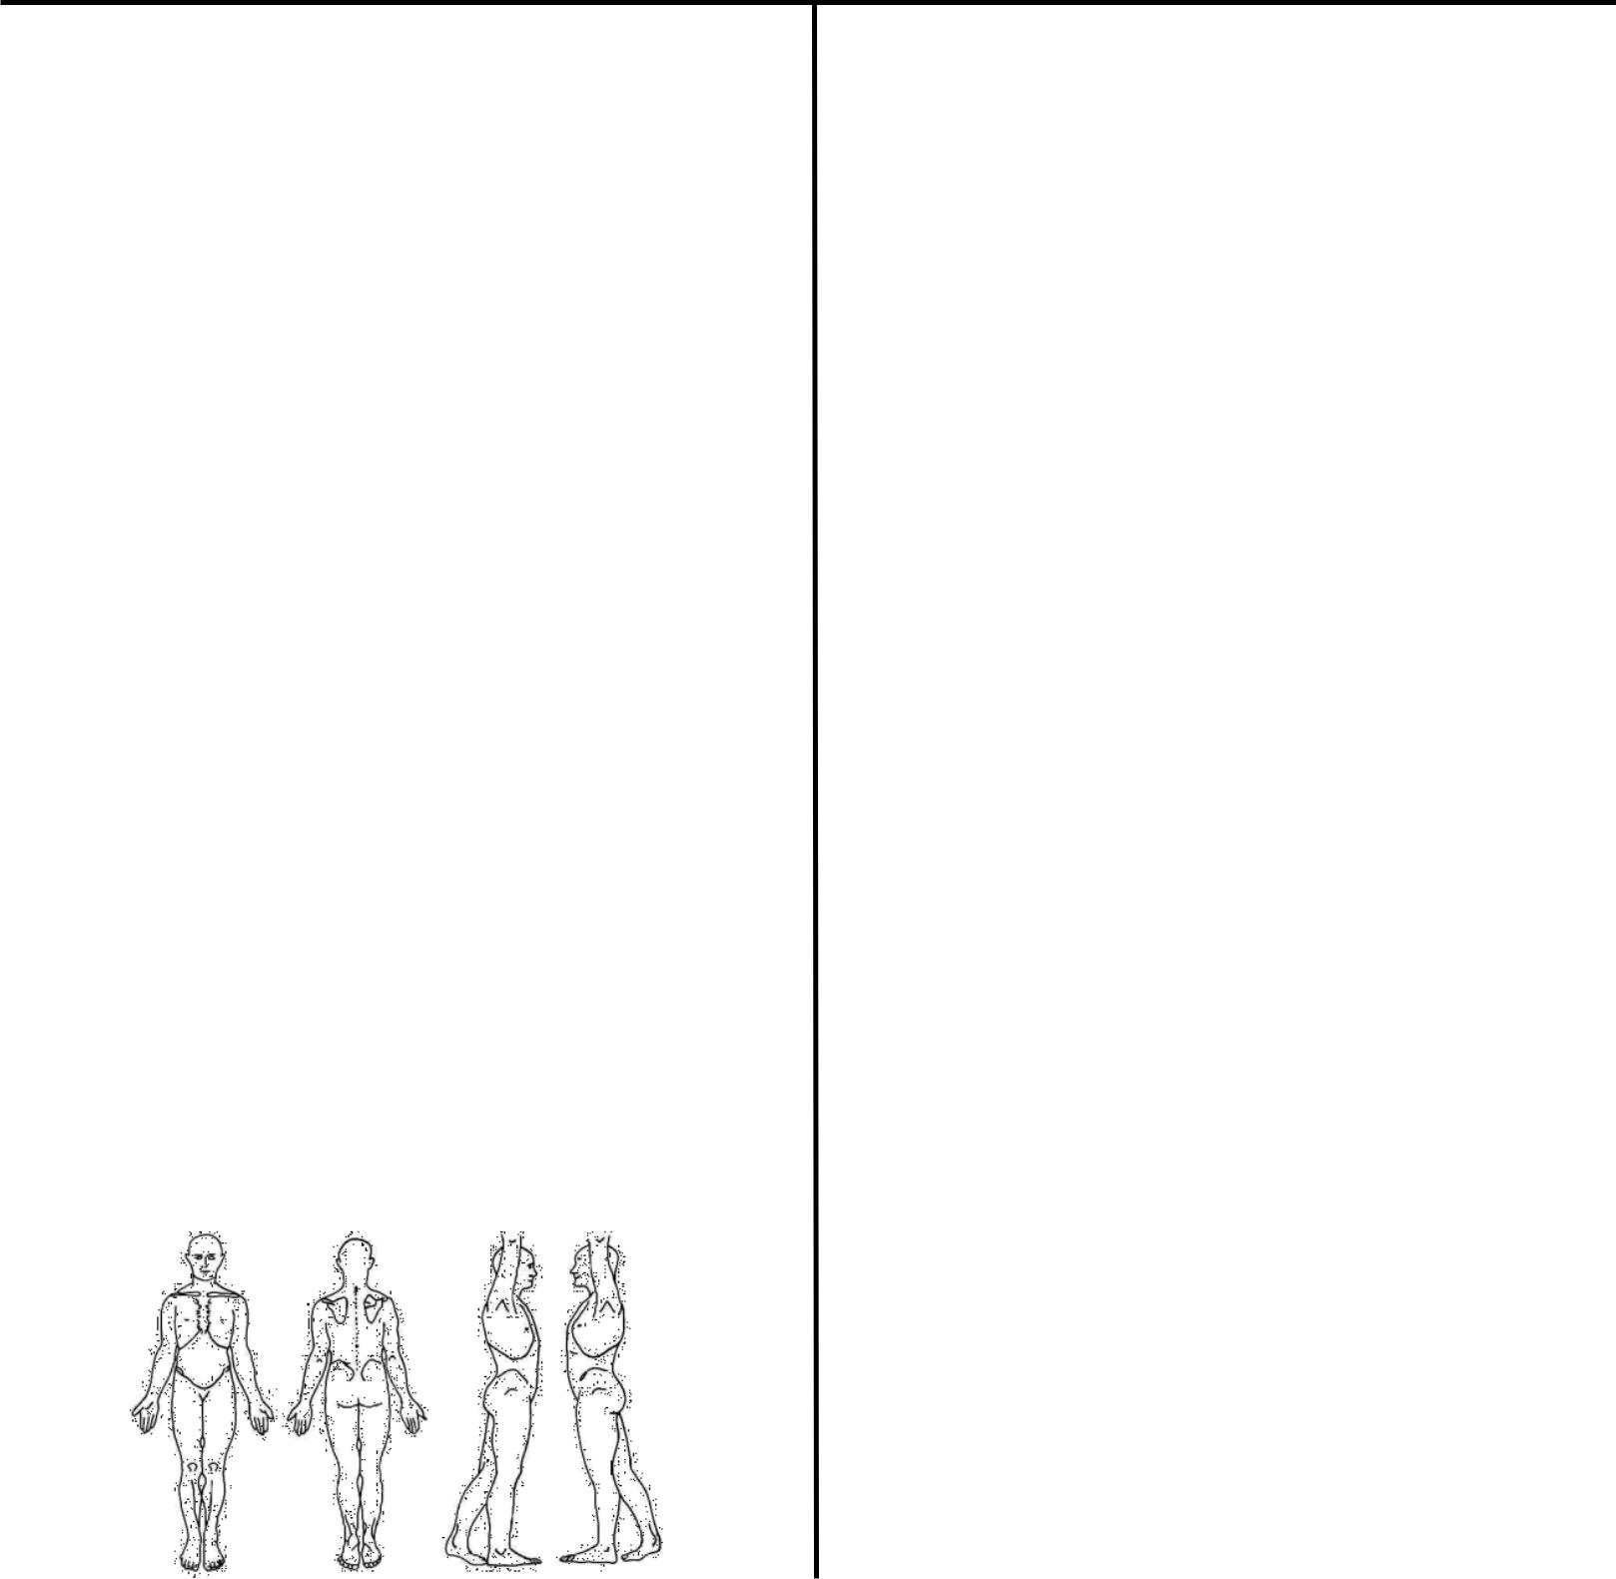
Massage Information

Please take a moment to carefully answer the following questions. If you have a specific medical condition or specific symptoms, massage may be contraindicated. A referral from your primary care provider may be required prior to services being provided.

Have you had a professional massage before?  Yes  No

If yes, how frequently do you get a massage? ________________

______________________________________________________________

If yes, do you pressure preference? Specify:
❑ light  medium  firm pressure

❑ Other ____________________________________________________

What type of massage are you seeking today?

- Relaxation  Deep Tissue  Therapeutic  Sports

- Pregnancy  Senior  Cupping  Hot Stones

- Other ___________________________________________________

What do you hope to accomplish from today’s massage?

_________________________________________________________________

Are you sensitive to fragrances or perfumes? |  |  | ❑ Yes | ❑ No
Do you have any known allergic reactions? |  |  | ❑ Yes | ❑ No
If yes, please describe ______________________________________
Do you have sensitive skin? | ❑ Yes | ❑ No
Do you exercise regularly? | ❑ Yes | ❑ No

What are your common areas of pain or tension? ________________

__________________________________________________________________

__________________________________________________________________

Are you aware of any tension holding spots in your body?  Yes  No

If yes, Circle any specific areas you would like the massage therapist to concentrate on during the session:

Medical History

Are you currently experiencing any of the following conditions?
❑ Flu or Cold  Inflammation  Fever  Infection

❑ Contagious Disease

Do you suffer from chronic or persistent pain/discomfort?

❑ Yes  No If so, for how long? __________________________

Do you know what causes/caused it or when the symptoms seem to get worse or better? __________________________________________

Do you see a chiropractor?  Yes  No

If so, how often? _____________________________________________

Are you currently under medical care?  Yes  No

Are you currently taking any prescription medication?

❑ Yes  No
If so, name meds and reason

__________________________________________________________________

__________________________________________________________________

__________________________________________________________________

Please indicate any condition that you have had or currently have:

❑ Headaches / Migraines  Varicose Veins

❑ Allergies / Sensitivity  Currently Pregnant

❑ Arthritis / Tendonitis  Blood Clots

❑ Bruise Easily  Epilepsy / Seizures

❑ Cancer / Tumors  Neck / Back Injuries

❑ TMJ Problems  Diabetes

❑ Abnormal Skin Condition  Paralysis

❑ Heart / Circulation Problems  Fibromyalgia

❑ Joint Replacement / Surgery  Numbness

❑ High / Low Blood Pressure  Sprains, Strains

❑ Major Accident  Recent Injuries

❑ Lack Of -or- Reduced Feeling / Sensation________________

Explain any condition you have marked above:

___________________________________________________________________

___________________________________________________________________

Are there any other health concerns you wish to discuss today?

Yes No If yes, please describe:________________________

Client Consent for Treatment

Please read carefully and sign below.

By signing this consent, I agree that I have stated all conditions that I am aware of and the information is true and accurate to the best of my knowledge. I will inform my health care provider and massage therapist if anything changes in my status. I understand that the massage/bodywork I receive is for the purpose of stress reduction and relief from muscular tension, spasm or pain and to increase circulation. If I experience any pain or discomfort, I will immediately inform my massage therapist so that the pressure and/or methods can be adjusted to my comfort level.

I understand that a massage therapist cannot diagnosis illness, disease, or any physical or mental disorders. As such, the massage therapist does not prescribe medical treatment or pharmaceuticals, nor do they perform any spinal or skeletal manipulations. It has been made very clear to me that this massage therapy is not a substitute for medical examinations and/or diagnosis and I understand that it is my responsibility to consult a physician for any ailments I may have.

Given the above, I understand that response to treatment varies on an individual basis and that specific results are not guaranteed. I understand that I am receiving massage therapy at my own risk. In the event that I become injured either directly or indirectly as a result, in whole or in part, of the aforesaid massage therapy I hereby hold harmless and release from any liability Amy Wiltgen, L.M.T., as well as any officers, directors, or employees of Breathing Space Therapies LLC for any condition or result, known or unknown that may arise as a consequence of any treatment that I receive. Sexual advances and other verbal or physical conduct of a sexual nature will constitute as sexual harassment and will not be tolerated, resulting in immediate termination of the session and I will be liable for payment of the scheduled treatment.

I agree to abide by a 24 hour cancellation notice for any scheduled massage. I understand I may be charged up to the full amount of service for missed appointments or for any cancellations with less than a 24 hour notice. I understand that if I arrive late for an appointment, the session will end at the original scheduled time to prevent penalizing another client. However, if the massage therapist is late, they will fulfill the scheduled massage length or offer a reasonable compensation.

I agree that I am of legal age (18 years old) and that if I am not, I agree to have my parent or guardian sign a parental/guardian release form before treatment.

Print Name: ________________________________________________________________

Signature: __________________________________________________________________

Date: __________________________

If you are unable to keep your appointment, please give us 24 hours notice.

